

# AMERICAN INTERNATIONAL UNIVERSITY-BANGLADESH (AIUB)

Faculty of Engineering

Bachelor of Science in Electrical and Electronic Engineering (EEE) BAE 2101: Computer Aided Design and Drafting

**Experiment # 08:** Understanding and drawing the proper Electric Conduit Layout based on Civil planning using AutoCAD software**.**

**Objective:** To familiarize students with proper understanding of drawing electric conduit layout diagram based on civil planning using AutoCAD software.

# Conduit Layout:

* **Layer 1**: First of all, change the symbols of fittings and fixtures with those assigned for conduit layouts. Try to use smaller symbols to indicate the fixture locations because we just need to identify the load position and type. Wire all the rooms individually. Connect each load from its parent switchboard. Choose appropriate wires depending on the load power. Take help from the power ratings of commonly used household appliances. Mark the conduits accordingly (C1,C2…..).
* **Layer 2**: Now, connect all the high power loads (15A, 20A) directly from the SDB. These loads should not be connected through any switchboard. Rather these should be supplied through separate MCBs. Choose appropriate wires and conduits using the table of current rating for different cables. You must use matched ECC for these high power loads
* **Layer 3**: It’s time to join the all the SBs to SDB. You can either connect each SB to the SDB through separate conduits or you can also create group of SBs and then drawing only one pair of cables to each group. While grouping, you must ensure that the group sizes (on the basis of connected loads to each groups) are much or less balanced. Otherwise the purpose of grouping is not satisfied. Try to group nearby switchboards and also keep it in mind that the combined load should not be excessive which would demand coarse wire.
* **Layer 4**: Now place antenna and telephone connections from respective junction boxes. You must ensure that these signal level cables are drawn through separate conduits rather than using the conduits containing power cables. Otherwise interference may occur. The antenna and telephone cables may be drawn through roof or lintel levels. Even some prefers to draw it through skirting levels. If you use skirting level, then door crossings must be avoided. Since antenna/telephone are low power signals and we do not need to control these through switches, there is no need to draw separate circuits for all the outlets from the junction boxes. Simply draw parallel connections from the junction box to each outlet. Don’t bother about cable/conduit size as for the power appliances. Setup the calling bell connection. Any existing conduit can be used to carry these wires if there are enough space through the conduits.
* **Layer 5**: Draw the main incoming cable from MDB to each SDB. Also demonstrate where the PVC risers (carrier of main power cables) should be placed. The symbols to be used for Conduit Layout are rather flexible. You can define your own symbols. You must also attach the ‘Legend’ which would suggest the meanings that your symbols carry. Use separate drawing sheets for concealed conduits, and conduits through floor finish.

# Sample Drawing:

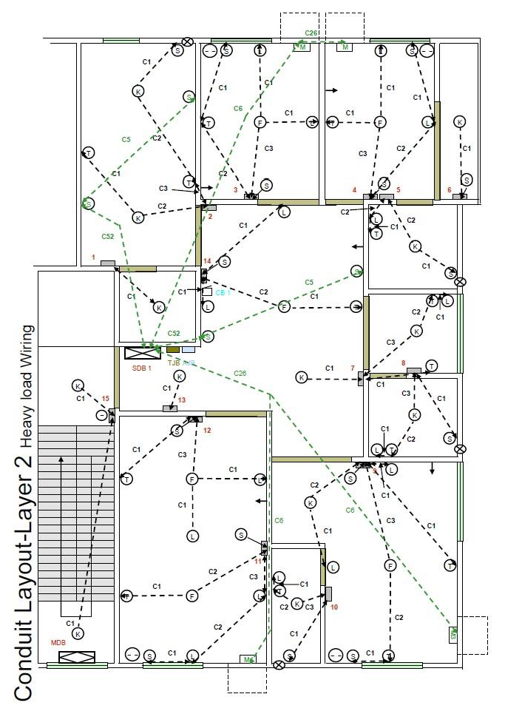

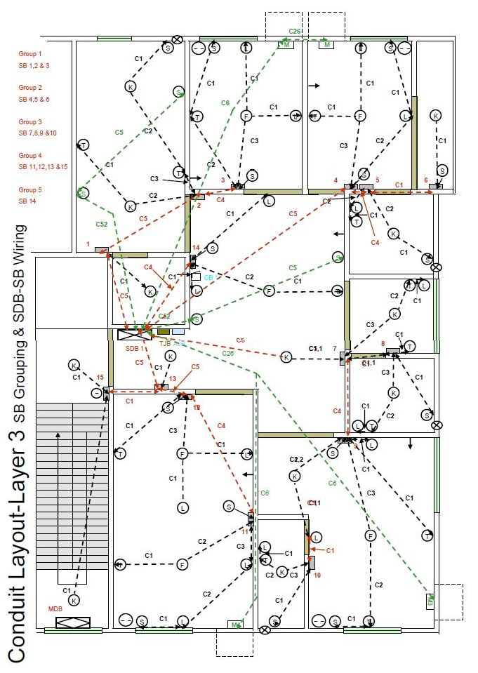

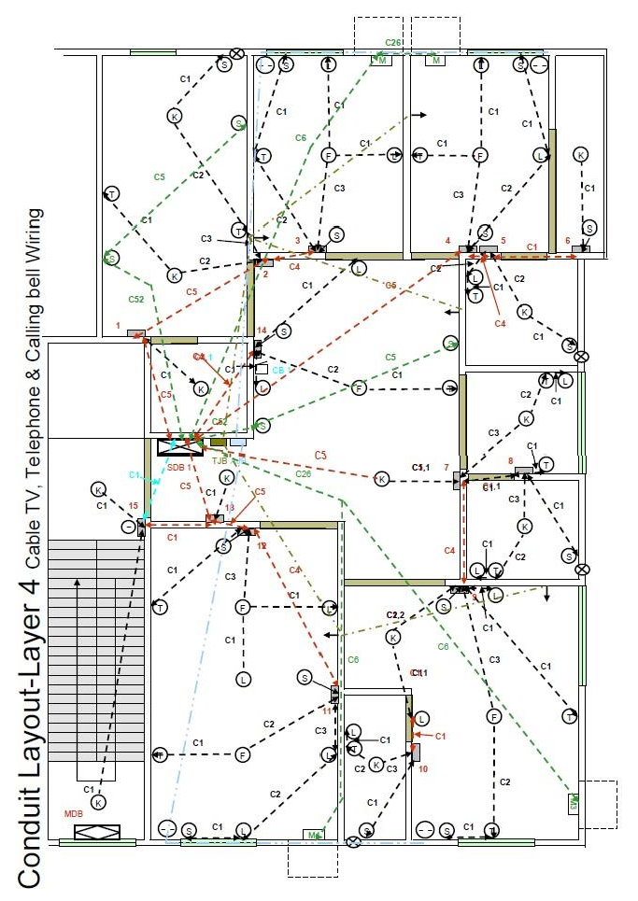

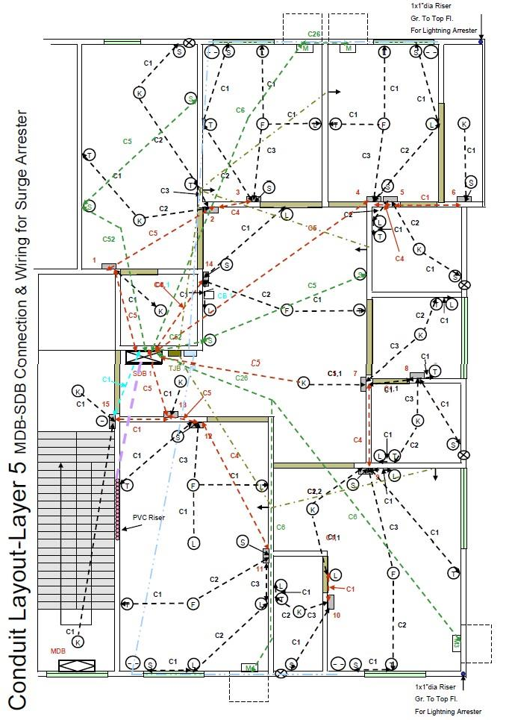

**Pre-Lab Homework:**

Student must show any kinds of homework that might be assigned. The homework should be done with AutoCAD software, and must be presented before the start of the experiment.

# Discussion and Conclusion:

Interpret the findings and determine the extent to which the experiment was successful in complying with the goal that was initially set. Discuss any mistake you might have made while conducting the investigation and describe ways the study could have been improved.

# References:

1. Kristen S. Kurland, “AutoCAD 2004, 2D Training Manual”.
2. Bob McFarlane, “Beginning AutoCAD 2004”.
3. David Byrnes and Mark Middlebrook, “AutoCAD 2007 For Dummies”.